Skills for Difficult Situations – Insight, Courage, Decisiveness, and Tact

We've been talking about leadership attributes as depicted on the whiteboard from our last class, shown below. Project Managers should be good leaders because people skills and good communication skills are important to being successful.

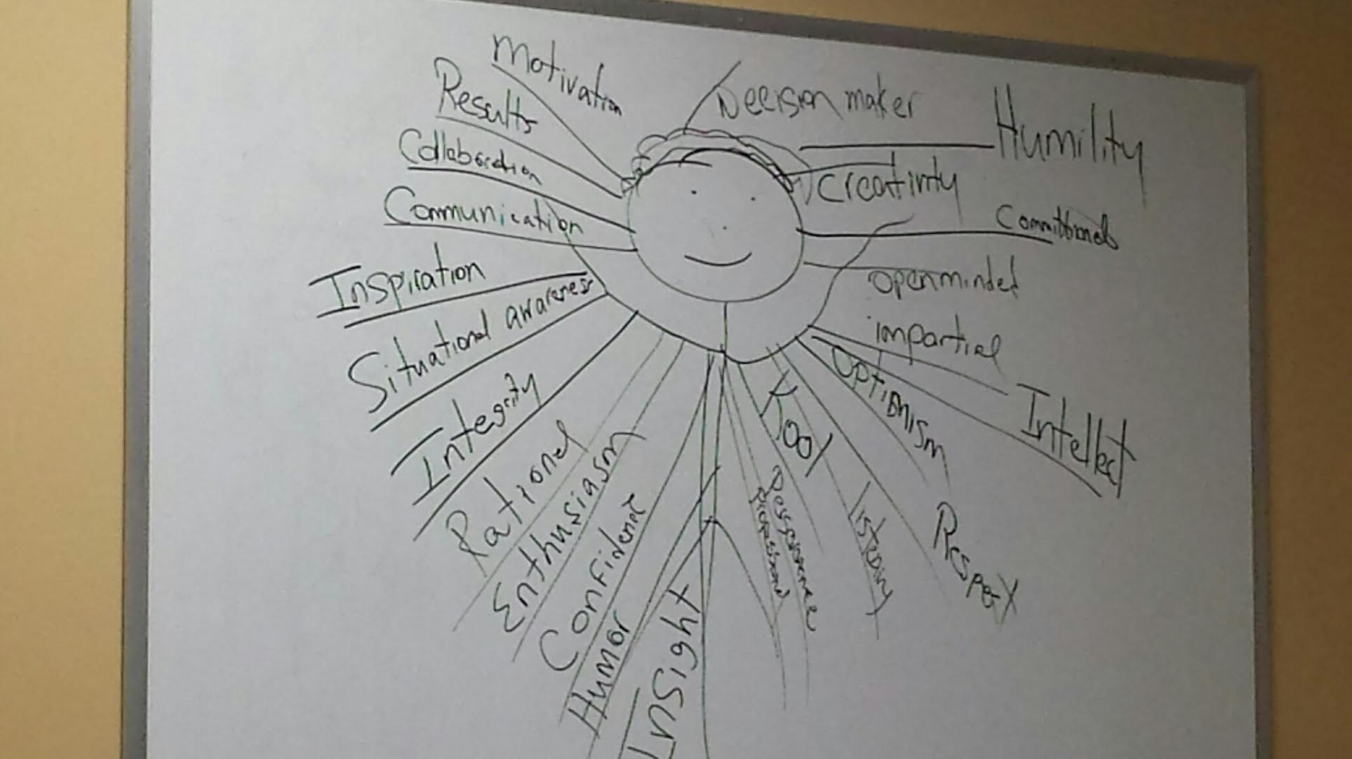

I would like to enhance myself in this way: To become able to take appropriate action in most situations. I am listing the following four effective project management skills to focus on enhancing myself. Taking appropriate action in some situations, can be difficult in the face of adversity or fear of failure. This difficulty can be managed by four leadership skills: insight, courage, decisiveness, and tact. We should have insight of a person, with tact to know what and how to communicate, and have courage to be decisive about the issues.

My strategy to improve these areas for myself begins with the definitions of the terms (Definitions in Oxford dictionary (American English) (US), 2015):

Insight – The capacity to gain an accurate and deep intuitive understanding of a person or thing

Courage – The ability to do something that frightens one.

Decisive – 1. Settling an issue; producing a definite result. 2. (Of a person) having or showing the ability to make decisions quickly and effectively.

Tact – Adroitness [cleverness or skill] and sensitivity in dealing with others or with difficult issues.

The second step of my strategy is to compile stories that demonstrate an example of such skills in a difficult situation. My initial example is from the movie shown in class (Remember the Titans (2000) - IMDb, 2016),” which shows how Gerry Bertier [team captain] builds up the courage to be honest and objective with Julius Campbell [other team leader]. It can be watched online for free (Remember the Titans HD full - Denzel Washington movies full movies - YouTube, 2015). In a scene 37 minutes into the movie, right after the water table was knocked over, the following dialog occurs:

36:55 Gerry tells Julius he wants to end these 3-a-day practices and get this over with learning about each other. Julius says, “…honesty is not too high on your priority list.”

37:30 Gerry gets Julius’s attention by saying,

“Honesty. Honestly, I think you’re nothing [belittling]… Nothing, but a pure waste of God-given talent [praise]. You don’t listen to nobody man! Not even Doc [Coach Hines] or Boone [Coach Boone]! ...you’re leave one of your teammates out to dry, me in particular.”

38:00 Julius rebuttals,

“Why should I give a hoot about you [pause] huh? Or anybody else out there. You talk about being the Captain. A Captain is supposed to be a leader, right? You’ve been doing your job, right? Then why don’t you tell your white buddies to block for Rev better because they have not blocked for him worth a plugged nickel, and you know it! Nobody plays, yourself included! I’m supposed to wear myself out for the team? What team? No. No, what I’m going to do is, I’m going to look out for myself and I’m going to get mine.”

38:45 Gerry says, “See man, that’s the worst attitude I’ve ever heard.” Julius rebuttals, “Attitude reflects leadership, Captain.”

The third step of my strategy is to evaluate the result of the managed difficulty. Usually there is some follow-up action that needs to happen and it was probably negotiated during the stressful difficulty. Back to my example in the movie, Gerry could have been more tactful but Julius was listening very well. Later, Gerry follows-through and takes care of the problem with the following dialog:

43:30 During a Practice Play, Gerry confronts Ray about not blocking and it was a formal warning of further reprimand.

43:45 The Play was run again and this time, everybody did their job.

Gerry says to Julius, “You really sacked him Campbell [good job].”

Julius says, “Yeah, I really love a little contact Petey.”

44:50 Gerry yelled, “Left side!” Julius paused and yelled, “Strong Side!”

They repeated this chant, back and forth, eight times. The music climaxed and people’s expressions were exhilarating. It seems that the main issue – racism will not be tolerated – was addressed. And their comradery can now flourish, like it should. Then the team developed immensely from then on.

If a difficult situation is managed well, then tact was used, and the best efforts of all parties were conducted. The situation should be documented and further progress should be evaluated. This is a standard procedure in the military and in business and is known as a counseling session, a performance review, and a progress report.

# References

*Definitions in Oxford dictionary (American English) (US)*. (2015, Oct 22). Retrieved from Oxford Dictionaries - Dictionary, Thesaurus, & Grammar (Online): http://www.oxforddictionaries.com/us

*Remember the Titans (2000) - IMDb*. (2016, Oct 22). Retrieved from IMDb - Movies, TV and Celebrities - IMDb: http://www.imdb.com/title/tt0210945/?ref_=nv_sr_1

*Remember the Titans HD full - Denzel Washington movies full movies - YouTube*. (2015, Sep 10). Retrieved from https://www.youtube.com/watch?v=VjeoEsDPI9s